Leap seconds

Definition:
# Source: AI Source: Provided by: [Data Path: Persons Table -> ID Column: 1, Name_En Column: Motasem Essam] -> From: [ChatGPT] on [1/26/2026]
A leap second is an extra second occasionally added to the world’s official time (UTC) to keep clocks aligned with the Earth’s actual rotation.

Why leap seconds are needed
# Source: AI Source: Provided by: [Data Path: Persons Table -> ID Column: 1, Name_En Column: Motasem Essam] -> From: [ChatGPT] on [1/26/2026]
- Atomic clocks are extremely precise and run at a constant rate.
- But Earth’s rotation is not perfectly steady — it slowly changes due to gravity, tides, earthquakes, etc.
- Over time, this causes a small mismatch between:
  - Atomic time (very exact) and
  - Astronomical time (based on Earth’s rotation)
To fix this, scientists sometimes add 1 extra second to UTC.

How a leap second looks
# Source: AI Source: Provided by: [Data Path: Persons Table -> ID Column: 1, Name_En Column: Motasem Essam] -> From: [ChatGPT] on [1/26/2026]
Normally, a minute has:
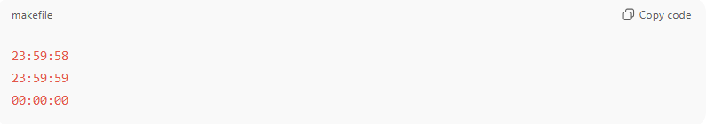
23:59:58
23:59:59
00:00:00
With a leap second, it becomes:
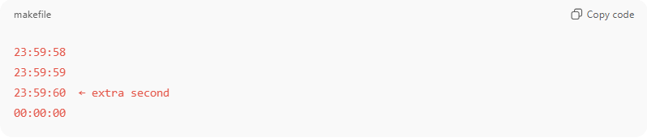
23:59:58
23:59:59
23:59:60 ← extra second
00:00:00

When leap seconds happen
# Source: AI Source: Provided by: [Data Path: Persons Table -> ID Column: 1, Name_En Column: Motasem Essam] -> From: [ChatGPT] on [1/26/2026]
- They are not regular (not every year).
- Added only when needed, usually June 30 or December 31.
- Since 1972, about 27 leap seconds have been added.

Who decides
# Source: AI Source: Provided by: [Data Path: Persons Table -> ID Column: 1, Name_En Column: Motasem Essam] -> From: [ChatGPT] on [1/26/2026]
The International Earth Rotation and Reference Systems Service (IERS) monitors Earth’s rotation and announces leap seconds.

Why they matter
# Source: AI Source: Provided by: [Data Path: Persons Table -> ID Column: 1, Name_En Column: Motasem Essam] -> From: [ChatGPT] on [1/26/2026]
Leap seconds help keep:
- Noon close to when the Sun is highest
- UTC aligned with Earth rotation
- Astronomical observations accurate
However, they can be tricky for:
- Computers and servers
- GPS and networks
- Some software systems

